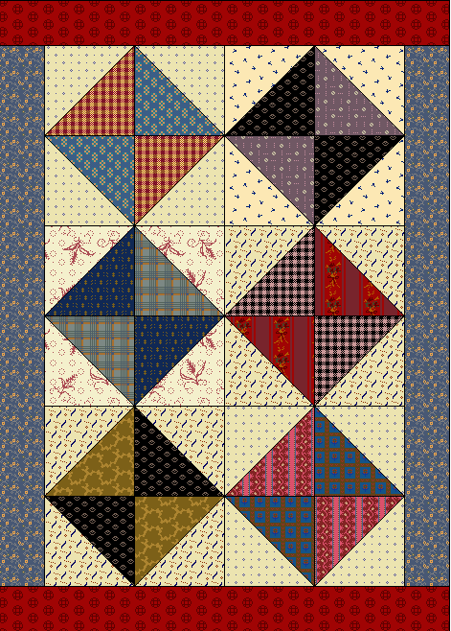
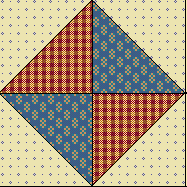

6-inch block

Materials needed
Scraps of assorted medium prints, at least 4" x 4"
Scraps of assorted light background prints, at least 4" x 4" (each block uses 2 matching squares)
1/8 yard of medium blue fabric for inner border
1/8 yard of red fabric for outer border
1/4 yd binding fabric
1/2 yard of backing fabric
18" x 20" piece of cotton batting
Cut:
12 squares, 3 7/8" x 3 7/8" from the assorted background prints, in matching sets of 2. Some prints may be repeated. Cut each square once on the diagonal.
12 squares, 3 7/8" x 3 7/8" from the assorted medium prints. Cut each square once on the diagonal.
2 strips, 2 1/2" x 18 1/2" from the blue print
2 strips, 2 1/2" x 16 1/2" from the red print
Directions:
1. Choose 4 matching light print triangles. Choose 2 sets of 2 matching medium print triangles. Arrange the light print triangles with the medium print triangles as shown in the block diagram. Stitch together. Press the seams. Make 6 blocks.
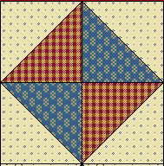

2. Sew the blocks together into three rows of 2 blocks each as shown. Press the seams in the opposite direction from row to row. Sew the rows together, and press the seams in one direction.

Sew the 2 1/2" x 18 1/2" blue border strips to the sides of the quilt top, pressing the seam allowances toward the border. Sew the 2 1/2" x 16 1/2" red border strips to the top and bottom of the quilt and press again.4.Layer the quilt top, batting and backing, and pin or baste the layers together.5.Try hand quilting in the ditch around the triangles and along the blocks for an antique look.6.Attach the binding to the quilt according to your favorite binding method.

